1. **Login** 
   1. **Admin Login**

|  |  |
| --- | --- |
| **User Story Definition** | As an Admin, I want to login so that I can redirect to Admin Home Page |
| **User Story ID** | 1 |
| **User Story Name** | Admin Login |
| **Details** | A registered Admin is able click Login link, after keying in Admin Username and Password field and get his credentials authenticated with the existing database entry |
| **Business Rules** | Admin should enter mandatory fields and user ID of one user can’t be similar to another user. All the fields have type constraints. |
| **Error Scenarios & Related Messages** | Login Fails, Generate Error Messages as Invalid Username or Password |
| **Acceptance Criteria** | If all the mandatory fields and type is matched, then Admin login will be successful |
| **Attachments** |  |

* 1. **Supplier Login**

|  |  |
| --- | --- |
| **User Story Definition** | As a Supplier, I want to login so that I can create Contract |
| **User Story ID** | 2 |
| **User Story Name** | Supplier Login |
| **Details** | A registered Supplier is able click Login link, after keying in Supplier Username and Password field and get his credentials authenticated with the existing database entry |
| **Business Rules** | Supplier should enter mandatory fields and user ID of one user can’t be similar to another user. All the fields have type constraints. |
| **Error Scenarios & Related Messages** | Login Fails, Generate Error Messages as Invalid Username or Password |
| **Acceptance Criteria** | If all the mandatory fields and type is matched, then Admin login will be successful |
| **Attachments** |  |

* 1. **Admin Registration**

|  |  |
| --- | --- |
| **User Story Definition** | As an Admin, I want to register so that I can login into Admin Home Page |
| **User Story ID** | 3 |
| **User Story Name** | Admin Registration |
| **Details** | Admin needs to fill some of the basic attributes/fields: First Name, Last Name, Age, Gender, DoB, Contact Number, Alternate Contact Number, Email Id, Password |
| **Business Rules** | Admin should enter mandatory fields. All the fields have type constraints. |
| **Error Scenarios & Related Messages** | If any field is missed then the Admin details will not be inserted into the database |
| **Acceptance Criteria** | If all the mandatory fields and type is matched, then supplier details will be successfully registered in the database. |
| **Attachments** |  |

* 1. **Supplier Registration**

|  |  |
| --- | --- |
| **User Story Definition** | As a Supplier, I want to register so that I can login into Supplier Home Page |
| **User Story ID** | 4 |
| **User Story Name** | Supplier Registration |
| **Details** | Supplier needs to fill some of the basic attributes/fields : First Name, Last Name, Age, Gender, Contact Number, Supplier Id, DoB, Alternate Contact Number, Email ID, Address, Zip Code, Password |
| **Business Rules** | Supplier should enter mandatory fields. All the fields have type constraints. |
| **Error Scenarios & Related Messages** | If any field is missed then the Admin details will not be inserted into the database |
| **Acceptance Criteria** | If all the mandatory fields and type is matched, then admin details will be successfully registered in the database. |
| **Attachments** |  |

* 1. **Supplier Automatic Rejection**

|  |  |
| --- | --- |
| **User Story Definition** | As a Supplier, I want to register so that I can login into Supplier Home Page |
| **User Story ID** | 5 |
| **User Story Name** | Supplier Automatic Rejection |
| **Details** | A registered Supplier is able click Login link, after keying in Supplier Username and Password field and get his credentials authenticated with the existing database entry |
| **Business Rules** | Supplier should enter mandatory fields. All the fields have type constraints. |
| **Error Scenarios & Related Messages** | If Supplier doesn’t approve by the Admin, Supplier will be automatically rejected. It shows “Login Denied by Admin” |
| **Acceptance Criteria** | If all the mandatory fields and type is matched, then supplier will be able to login |
| **Attachments** |  |

1. **Supplier**
   1. **Create Contract**

|  |  |
| --- | --- |
| **User Story Definition** | As a Supplier, I want to create Contract so that I can redirect to Contract creation |
| **User Story ID** | 6 |
| **User Story Name** | Create Contract |
| **Details** | On clicking Create Contract, it should redirect to the Contract Creation, Supplier should be able to Insert the Contract Description, Update Terms and Conditions and Set the Amenities |
| **Business Rules** | Supplier should provide the contract details. All the fields have type constraints. |
| **Error Scenarios & Related Messages** | Supplier failing to provide information on the mandatory fields be provided with an alert message as Please update the highlighted mandatory field(s) |
| **Acceptance Criteria** | If all the mandatory fields and type is matched, then contract will be created in the database. |
| **Attachments** |  |

* 1. **Edit Contract**

|  |  |
| --- | --- |
| **User Story Definition** | As a Supplier, I want to edit Contract details so that I can update the Contract details |
| **User Story ID** | 7 |
| **User Story Name** | Edit Contract |
| **Details** | When Supplier clicks Edit button, it should allow editing or modifying of the Contract Description, Terms and Conditions and Amenities |
| **Business Rules** | Supplier should edit the contract details. |
| **Error Scenarios & Related Messages** | Supplier failing to provide information on the mandatory fields as empty be provided with an alert message as Please update the highlighted mandatory field(s) |
| **Acceptance Criteria** | Contract details should be edited |
| **Attachments** |  |

* 1. **Delete Contract**

|  |  |
| --- | --- |
| **User Story Definition** | As a Supplier, I want to delete rejected Contract so that I can update the Contract details |
| **User Story ID** | 8 |
| **User Story Name** | Delete Contract |
| **Details** | When Supplier clicks Delete button, it should ask the confirmation from the Supplier to delete the entire Contract detail from the database |
| **Business Rules** | Supplier should delete the contract. |
| **Error Scenarios & Related Messages** | When there is no record, delete operation can’t be performed |
| **Acceptance Criteria** | Contract details should be deleted |
| **Attachments** |  |

* 1. **View Contract**

|  |  |
| --- | --- |
| **User Story Definition** | As a Supplier, I want to view Contract details so that I can able to know the approved/pending Contracts |
| **User Story ID** | 9 |
| **User Story Name** | View Contract |
| **Details** | When Supplier clicks on Contract List button, it should display all the Contracts created by the Supplier |
| **Business Rules** | Supplier should able to view the contract |
| **Error Scenarios & Related Messages** | When there is no Contracts created, then the list will be empty |
| **Acceptance Criteria** | Contract details should be viewed |
| **Attachments** |  |

* 1. **Track Contract Status**

|  |  |
| --- | --- |
| **User Story Definition** | As a Supplier, I want to view Contract Status so that I can able to know the approved/pending Contracts |
| **User Story ID** | 10 |
| **User Story Name** | Track Contract Status |
| **Details** | When Supplier clicks on Track status button, it should display the Contracts created by the Supplier |
| **Business Rules** | Supplier should able to view the contract |
| **Error Scenarios & Related Messages** | When there is no Contracts created, then the list will be empty |
| **Acceptance Criteria** | Contract Status should be viewed |
| **Attachments** |  |

1. **Admin**
   1. **Approve Supplier**

|  |  |
| --- | --- |
| **User Story Definition** | As an Admin, I want to approve/reject the Supplier so that the Supplier can create Contract |
| **User Story ID** | 11 |
| **User Story Name** | Approve Supplier |
| **Details** | The Admin should Approve/Reject the Supplier by clicking the Approve/Reject button |
| **Business Rules** | Admin should able to approve the supplier |
| **Error Scenarios & Related Messages** | If the supplier is not approved then the supplier is not able to login |
| **Acceptance Criteria** | Supplier should be approved to create contract |
| **Attachments** |  |

* 1. **Approve Contract**

|  |  |
| --- | --- |
| **User Story Definition** | As an Admin, I want to approve/reject the Contract so that the Contract can be maintained |
| **User Story ID** | 12 |
| **User Story Name** | Approve Contract |
| **Details** | The Admin should Approve the Contract by clicking the approve button |
| **Business Rules** | Admin should able to approve the contract |
| **Error Scenarios & Related Messages** | If the contract is not approved then the supplier is not able proceed with the contract |
| **Acceptance Criteria** | Contract should be approved to be processed |
| **Attachments** |  |

**ATTACHMENTS**

1. **Login**
   1. **Admin Login**

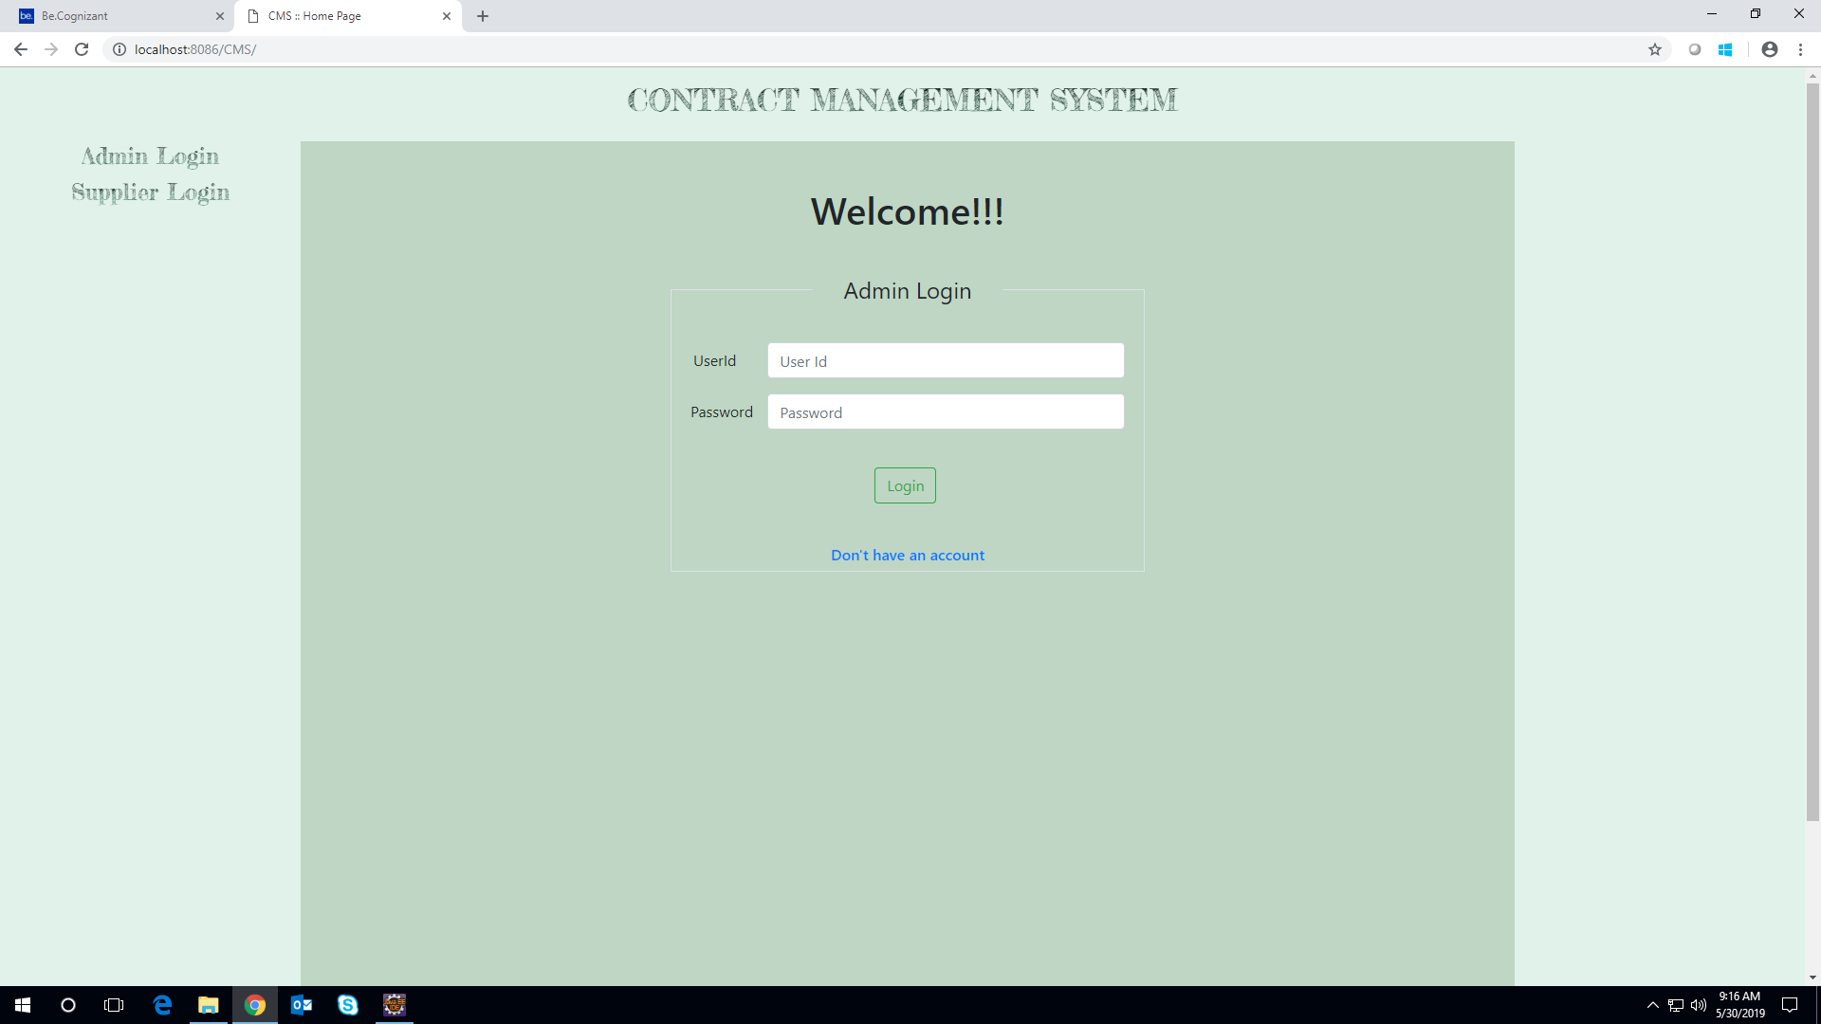

* 1. **Supplier Login**

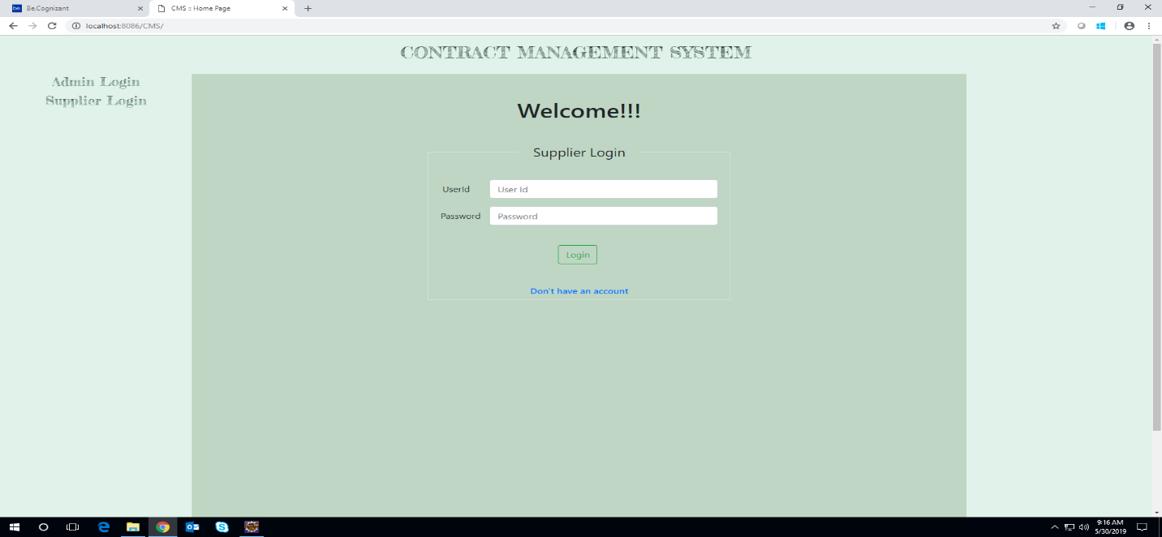

**REGISTRATION**

* 1. **Admin Registration**

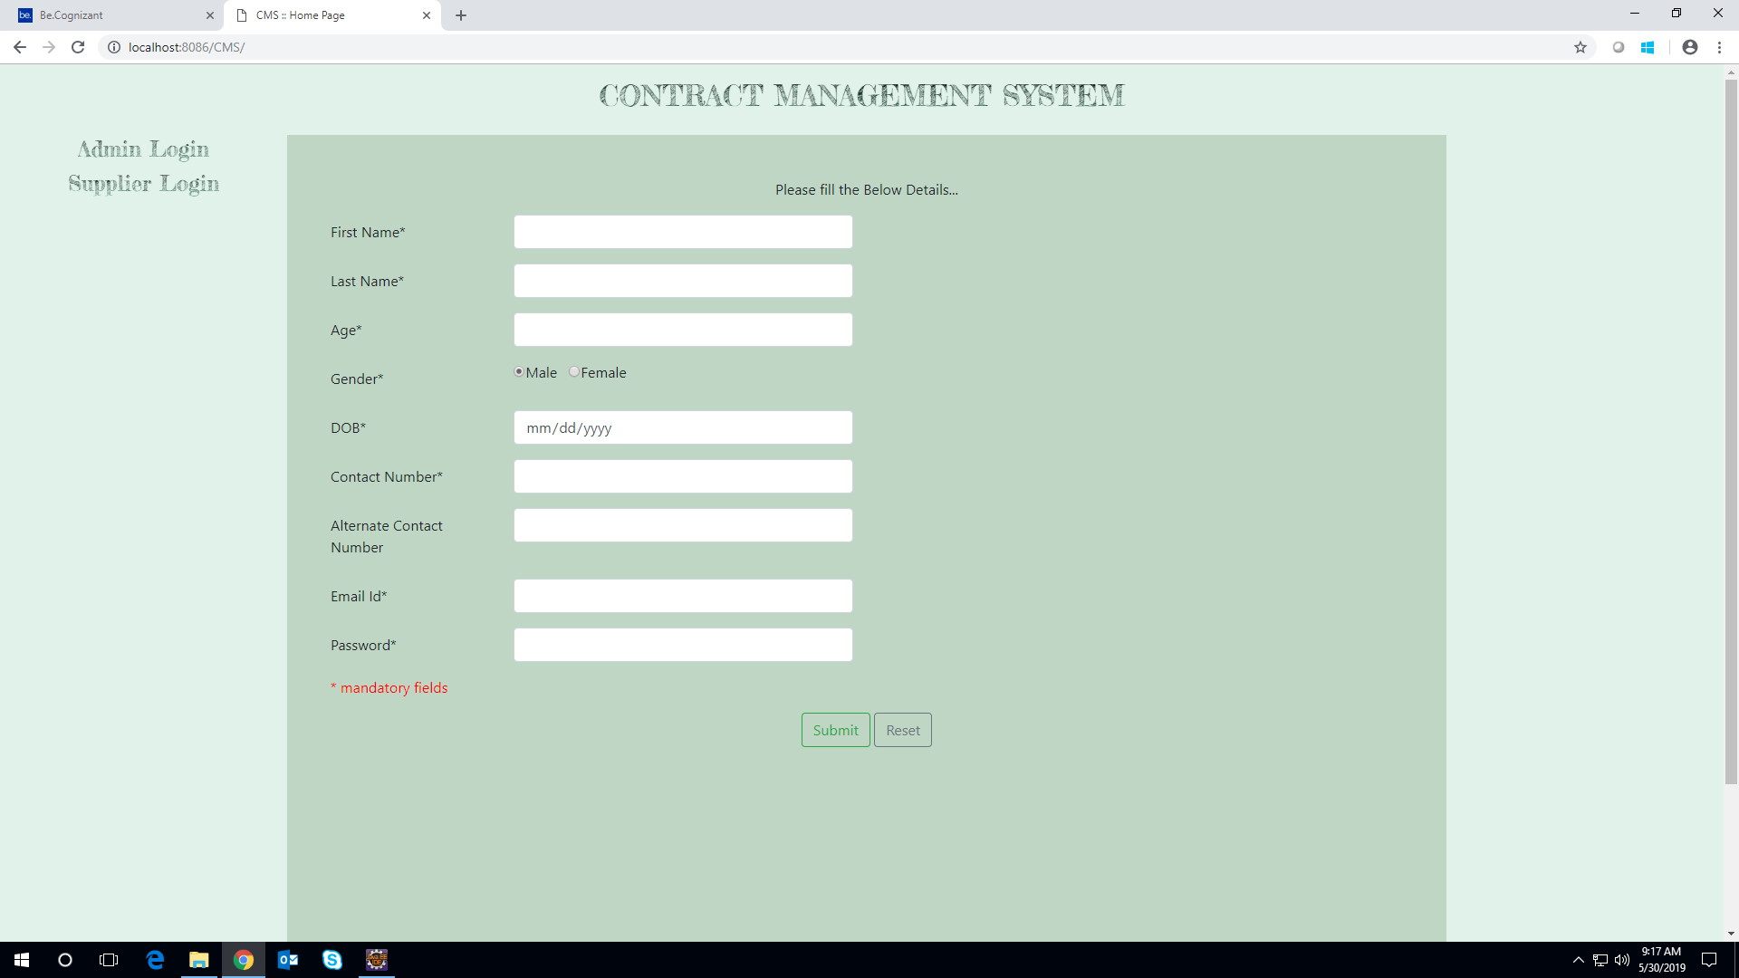

**1.4 Supplier Registration**

